Procedure for balancing and calibration of sGGG July 2010 (in air)

The system is designed by so that the capacitance cage (assembled and never to be disassembled, rigid with the shaft; Fig. 1, left picture) is by construction at the right location in between the test cylinder (Fig. 2, right picture) when they are in the nominal configuration in which the coupling arm is perfectly vertical. The “right” location has been computed by Gian Luca and Erseo taking into account the curvature of the plates and test cylinders surfaces (Gian Luca to provide the calculation) and it turns out to be such that the cage should be closer to the inner cylinder than to the outer one by 50 μm. There is no way of adjusting this configuration: the central cardanic suspension (connecting the coupling arm to the shaft) cannot be moved, therefore the relative position of the cylinders w.r.t. the cage cannot be changed. The cage is an assembled system and individual plates cannot be moved. This was done on purpose because adjustments would be too difficult; we therefore decided to rely on construction.

Note: it would have been wise to measure with the DEA machine the cage + the outer surface of the inner cylinder and the inner surface of the outer one to establish how good the construction was.

The adjustments required are (in order of priority):

Shaft: the shaft (spindle plus rest of the shaft below – see Fig. 1) must be vertical otherwise the cage moves relative to the test cylinders and this is equivalent to a common mode displacement of the cylinders. Verticality of the spindle is equivalent to horizontality of the fennel shaped steel flange in which the ball bearings holding the spindle are inserted. In the preliminary phase in which the system is mounted on a temporary frame as in Fig. 2, the horizontality of the steel flange is checked with Erseo’s spirit level and corrections are made with the ordinary screws (ends sharpened by Donato). Once this is done, verticality of the rest of the shaft with the spindle (no tilt) is checked with a comparator and corrected by placing appropriate spacers on appropriate locations of the bayonet attack. After sGGG will be mounted on the fixed frame with the cardanic suspension, the steel flange can be adjusted in the plane of its mounting on the suspended frame so as to align the rotor axis with the vertical axis of the suspensionin vacuum, only the steel flange can be adjusted with PZTs capable of 90 µm travel range.

we can make are the following:

Shaft: the verticality of spindle (see Fig 1) can be
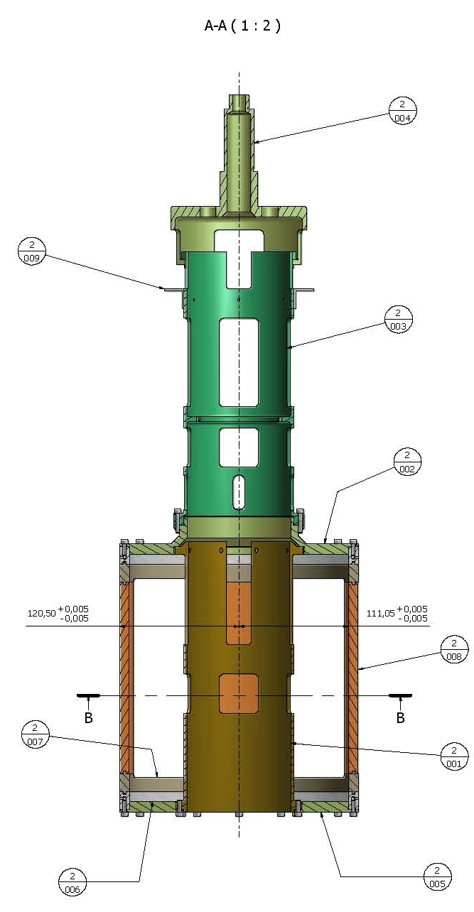 | 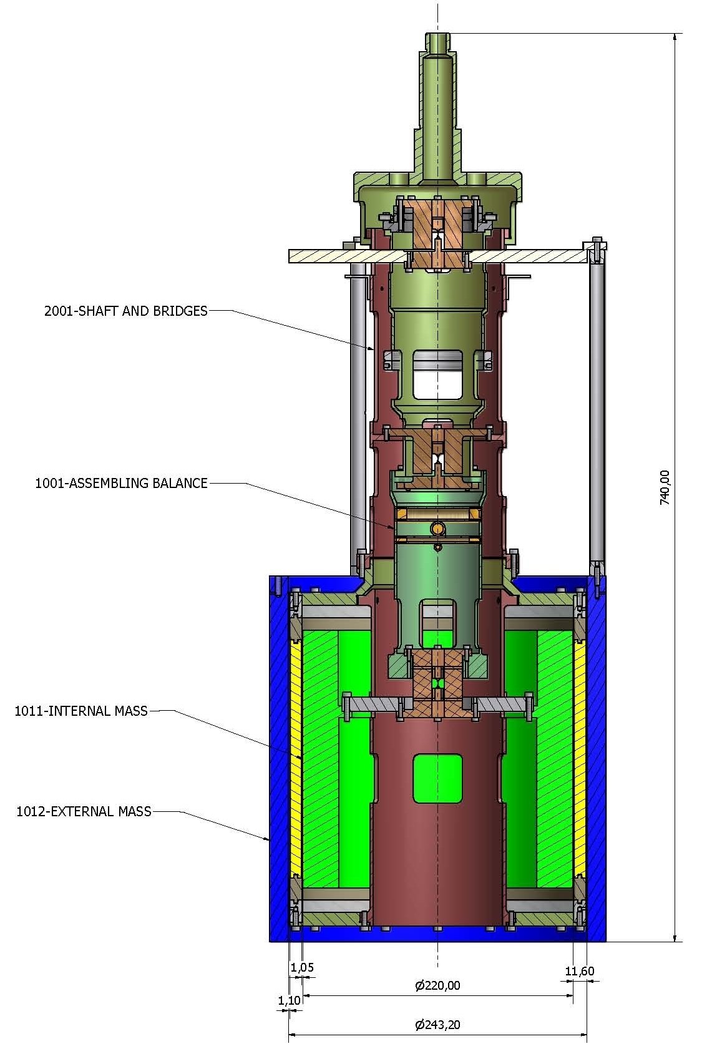
Fig. 1: Left: Spindle (at the top, shown in light green) to be inserted in ball bearings inside the fennel shaped steel flange (not shown), shaft and capacitance cage. The spindle is connected to the rest of the shaft below with a bayonet attack. Right: sGGG balance mounted on the shaft. At the bottom the numbers show that the gap between the capacitance plates and the inner cylinder is 1.05 mm, while the gap between the capacitance plates and the outer cylinder is 1.1 mm. So, the inner gap differs from the outer one by 50 microns (the inner cylinder is closer to the plates; see calculations by Gian Luca and Erseo to take into account that the plates are not planer but curved)

The system is mounted as in Fig 1. on a temporary frame.

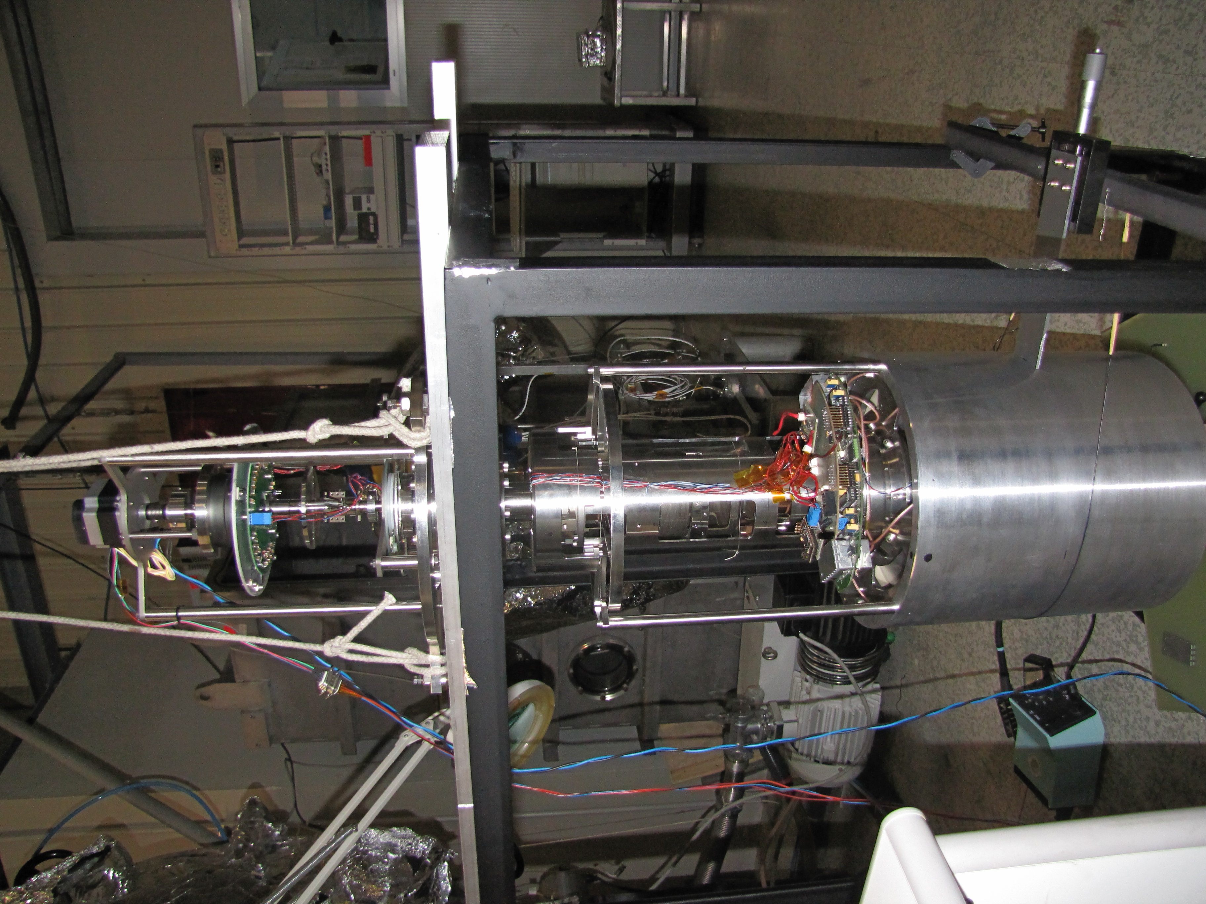 | 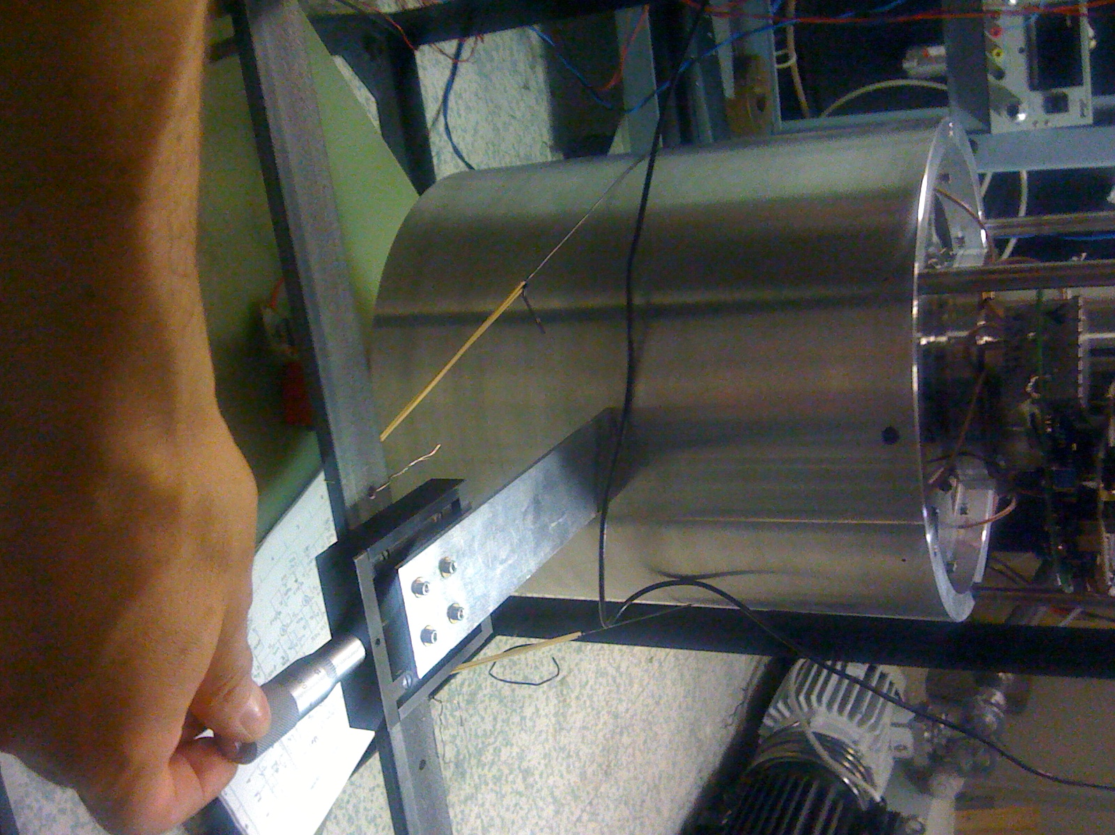
Fig. 2: sGGG system mounted on a temporary frame. The micrometric screw allows to move the outer test cylinder by a given amount. The pictures show the system when an elastic (shown in yellow) holds the outer cylinder; the elastic will be used in some cases (as specifically explained) but note that if we want both masses free to move the elastic should not be in place

1. Verticality of the spindle (top part of shaft) held by ball bearings inside the fennel shaped steel flange

In this temporary setting the steel flange is positioned with 3 normal screws. We use the spirit level of Erseo to put this flange horizontal (i.e. spindle vertical). This spirit level has a resolution of 2x10^-5 rad, and we think we have places it horizontal to a few times that much. Since the masses are about 0.5 m down, a flange horizontal to 10^-4 rad means (if the whole shaft is aligned with the spindle – i.e. baionet attact is perfect) that the shaft (hence the capacitance cage rigid with it) is displaced by 50 micron from its nominal position in between the test cylinders

Re

Fig. 2: Left: Spindle (at the top, shown in light green) to be inserted in ball bearings inside the fennel shaped steel flange (not shown), shaft and capacitance cage. The spindle is connected to the rest of the shaft below with a bayonet attack. Right: sGGG balance mounted on the shaft. At the bottom the numbers show that the gap between the capacitance plates and the inner cylinder is 1.05 mm, while the gap between the capacitance plates and the outer cylinder is 1.1 mm. So, the inner gap differs from the outer one by 50 microns (the inner cylinder is closer to the plates; see calculations by Gian Luca and Erseo to take into account that the plates are not planer but curved)
etry due to the electronics?

